A Report

On

**Comparative LCA of Hydrogen with Conventional Gasoline and Diesel**

Prepared in partial fulfilment of

the Engine, Motors, Mobility Course ME F317

Under the guidance of

**Dr. Saket Verma, IC**

(Instructor, ME F317 EMM)



Birla Institute of Technology and Science, Pilani

11th December 2022

Prepared by

Chaitanya Krishna Chauhan

2020A4PS1869P

**LIST OF CONTENTS**

1. Introduction 3

1.1. Why use Alternative fuels? 3

2. Material and Methods 4

2.1. Classification of Hydrogen 4

2.1.1 Blue Hydrogen 4

2.1.2 Grey Hydrogen 4

2.1.3 Green Hydrogen 4

2.2. Technical details of Hydrogen as a fuel 5

2.3. Applications of Hydrogen fuel cell 5

2.4. Advantages over gasoline and diesel 6

2.5 Comparison 7

2.6 Disadvantages 7

2.7 Future Trend 8

Conclusion 9

References 10

1. Introduction
   1. Why use Alternative fuels?

Conventional fuels account for over 80% of energy used all over the world. Transportation is an inevitable part of our day-to-day life and can’t be overlooked. The whole world can come to a standstill if the transportation stops for a single day. However, it’s quite evident that though necessary, transportation is also impacting the environment and causing many health hazards.

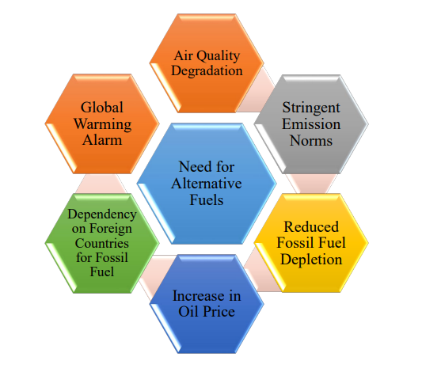

The major problem is that the common vehicles like cars and bikes use gasoline for the fuel. Gasoline is one of the most hazardous fuels because of enormous pollutants emission that lead to respiratory ailments, stroke, asthma and in some cases, early death. (Anastasia, 2019) Apart from that, these toxic emissions only add up to the global warming and climate changes all over the world. Another prime issue in the gasoline fuel is that its source product oil has to be imported from other countries. In this way, we are dependent on other countries for the fuel as well.

Alternative fuels are currently one of the popular topics growing interest worldwide. We can reduce carbon emissions if we start using alternative fuels in place of fossil fuels (such as gasoline and diesel) which contribute to increasing carbon footprints. Conventional fuels are limited and non-renewable and hence, will run out with time. To avoid a crisis on a later stage, we should start using fuels other than the petroleum fuels to reduce pollution and encourage sustainable development. (Carless, 1993)

1. Material and Methods
   1. Classification of Hydrogen

There are majorly four types of hydrogen: grey hydrogen, blue hydrogen, green hydrogen. The classification is done on the basis of energy spectrogram and the names given are just colour codes used to distinguish between them.

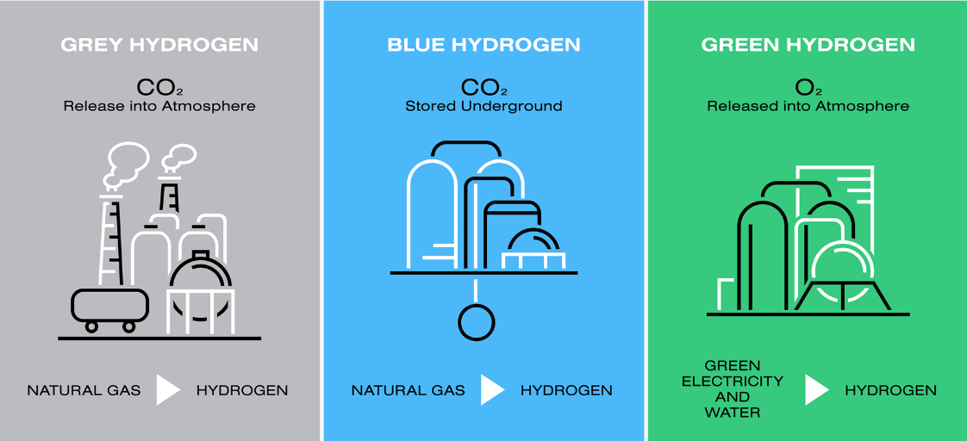

* + 1. Blue Hydrogen

Blue hydrogen is a prime element of the circular carbon economy and is an industrial term for hydrogen produced by natural gas. Its speciality is that we capture the CO2 emissions and either recycle, reuse or remove them. This converts maximum energy of hydrocarbon (around 80%) to hydrogen fuel as well as utilize the capture CO2.

* + 1. Grey Hydrogen

It is the most common form of hydrogen and is prepared from fossil fuels or methane using SMR process. (Steam Methane Formation). Unlike blue hydrogen, the CO2 emissions isn’t captured in this hydrogen.

* + 1. Green Hydrogen

Green hydrogen as the name suggests is the type of hydrogen which is produced without the production of harmful greenhouse gases like CO2. It is made using clean electricity processes using renewable energy resources like solar or water energy.

* 1. Technical Details of Hydrogen as fuel

The table 2.2.1 shows the energy content comparison of various fuels. We can clearly see that hydrogen is quite efficient as compared to other fuels in terms of fuel energy. It has the ability to power zero emission vehicles. It is also a colourless, clean fuel that emits only water when burnt or oxidized. It is stored in liquid form at a temperature of around -253 degree Celsius highly compressed at around 350 to 700 bars. It has an advantage of high energy density. Its energy density is 120MJ/Kg.

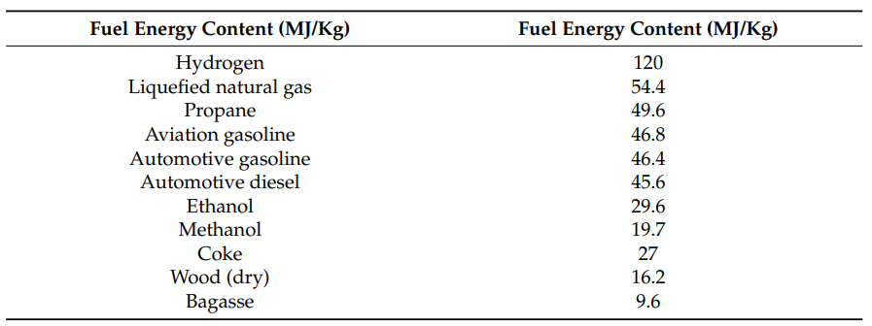The Hydrogen Fuel Cell consists of reformer (fuel processing unit), power conditioning unit and the fuel cell stack.

Table 2.2.1 (Qazi, 2022)

Results show that with an increase in compression ratio of hydrogen, the brake thermal efficiency increases. At a Brake Mean Effective Pressure (BMEP) of 0.33 Megapascal (MPa), highest brake thermal efficiency of 37 % is achieved at a compression ratio of 11 compared to 28 % for a compression ratio of 6. (Singh, 2016). Hydrogen fuel cells can be used to power any device that uses electricity. So, they can be used to power vehicles that run off electricity. (SEPUP, 2022)

* 1. Applications of Hydrogen fuel cell

1. Hydrogen is an energy carrier and can not only produce but also store tremendous amount of energy.

2. As fuel cells for light-duty highway vehicles. (Reducing 50-90% of emission) 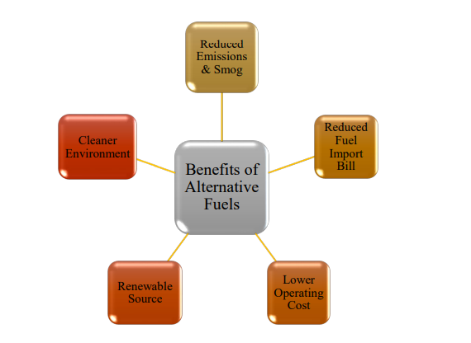

3. Convenient fuel for heavy transports, trains, warehouse logistics like forklift etc.

4. As a backup power resource for uninterrupted power supply in hospitals and other critical places.

5. Mobile power generation to provide electricity for rockets and space shuttles.

6. In Marine applications used as an alternative to nuclear energy.

* 1. Advantages over gasoline and diesel

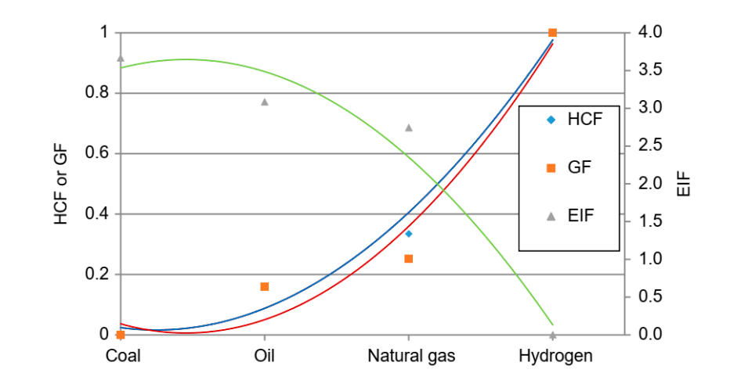Hydrogen is the most abundant element in the universe. Hydrogen fuel cells provide a promising alternative to internal combustion (IC) engines because of their clean exhaust emissions, higher efficiencies and renewable fuel sources.

Figure 2.2.1

Figure 2.2.1 shows the variety of fuels and their performance indexes. GF is Greenization factor, HCF is hydrogen content factor and EIF is environmental impact factor. The figure shows that with increasing hydrogen content (HCF increases), we get greener energy resources (GF increases) and the impact on environment is decreased. (EIF decreases)

The advantage of gaseous fuel is that it mixes homogeneously with air to produce an air-fuel mixture without physical delay. (Kavathekar, 2021). The chemical structure of the fuel is advantageous as the carbon-hydrogen bonds in methane reduce carbon dioxide emissions per unit of energy compared to diesel and gasoline.

.

* 1. Comparison

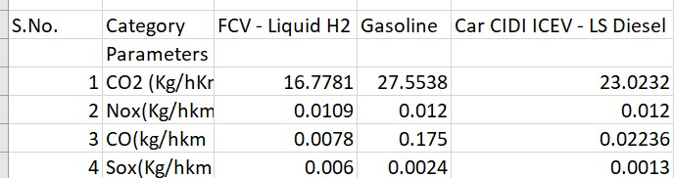

Hydrogen is a much cleaner fuel when compared to gasoline or diesel. Data from GREET, a Life Cycle Assessment software shows that when compared for emission from Well to Wheel (WTW), Gasoline and Diesel have significantly higher emission with respect to CO2, NOx, SOx and CO. These four are the major pollutants and lead to major problems. The readings from the LCA software GREET matches the emission rates from various sources, such as those of CO2 emission.

2.6. Disadvantages

1. Hydrogen can also cause a lot of pollution if not produced using renewable resources. (96% of hydrogen used is grey).
2. Difficult to handle being a gas. It has to be stored in liquid compressed form at high pressure. (350 to 700 bar).
3. It is difficult to transport hydrogen fuel to gas stations with the existing pipelines for natural and methane gas. Cost ineffective as new pipelines would be required otherwise, a mixture of low content hydrogen with natural gas has to be passed.
4. It is less advantageous when compared to electrically powered vehicles and relatively expensive as well.

2.7. Future Trend

Hydrogen fuel cells can be found in many different places today. Because the technology is still developing, most fuel cell applications to date have been for demonstration projects. Applications have included small handheld devices, such as cell phones and laptop computers, electric vehicles, from passenger cars to buses, and stationary power for office buildings, hospitals, and other large commercial and institutional facilities. They are particularly useful in indoor warehouses to power forklifts because they don’t emit any toxic fumes. They are also used in remote places where access to a conventional power supply is limited or impossible, such as off-grid home-sites and field weather stations. Automobile manufacturers such as Honda, Toyota, and Hyundai have started to manufacture fuel cell vehicles (FCVs) with hydrogen as fuel. These FCVs are currently available in North America, Asia, and Europe, and have primarily been bought by early adopters. (Yogesh Manoharan, 2019). Currently fuel cells can be found from above the Earth (in the space shuttles) to below the ocean surface (in some of the most recent submarines), and they are likely to be used more in the future.

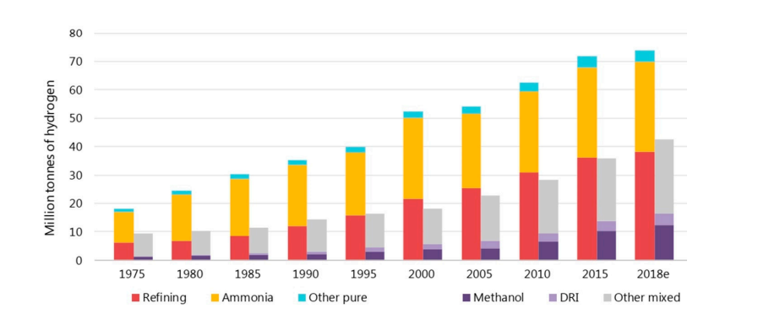

Figure 2.7.1

Figure 2.7.1 shows the increasing demand of Hydrogen since 1975.

**CONCLUSION**

The Fuel Cell Technologies continues to gain interest and promotes Research & Development activities. It is continuing to validate the technology in hydrogen stations, fuel cell vehicles, distributed generation, forklifts, and backup power. Analysis efforts explore not just upfront costs of hydrogen and fuel cell systems but also life cycle costs, and the analyses are used to guide research, development and demonstration (RD&D) efforts. The research program continues to leverage other hydrogen and fuel cell activities globally to multiply and maximize the impact of our efforts towards sustainability. The data analysis shows that it can certainly be a viable replacement to gasoline and diesel fuels.

# **References**

Anastasia. (2019). 10 Reasons to Use Alternative Fuels & The Future of Automobiles. *https://www.cleverism.com/10-reasons-to-use-alternative-fuels/*, 10.

Carless, J. (1993). *NYC GOV.* Retrieved from https://www.nyc.gov/html/dot/downloads/pdf/alternativefuel.pdf

Kavathekar, K. P. (2021). *Investigation on Performance and Emission Characteristics of Hydrogen Compressed Natural Gas HCNG Fuel in SI Engine.* Symbiosis International University: ShodhGanga.

Qazi, U. Y. (2022). *Future of Hydrogen as an Alternative Fuel for.* https://www.mdpi.com/1996-1073/15/13/4741.

SEPUP. (2022, 07). *The Lawrence, hall of science.* Retrieved from Hydrogen & Fuel Cells: Science Behind Fuel Cells: https://sepuplhs.org/high/hydrogen/hydrogen.html

Singh, I. (2016). *Use of biodiesel and hydrogen as fuel in C I engine.* ShodhGanga.

Yogesh Manoharan, S. E. (2019, 9 11). *MDPI.* Retrieved from https://www.mdpi.com/2076-3417/9/11/2296: https://www.mdpi.com/2076-3417/9/11/2296

# 